Note: Include this page only when adding / amending / deleting a document. If using this document as a record, this Revision History page can be omitted.

REVISION HISTORY

Revision no | Date | Description of Changes | Reason for Revision | Revised by | Approved by
1 | 01 June 13 | Add revision history page | - Recommendation from Stage 2 audit | RDPlacido
2 | 16 May 14 | Add revisions | IQA Findings | WRRobles
3 | Apr. 8, 2016 | Added disclaimer when printing the document | For document control | RCGanal | WRRobles
TM-BR-MG- 11 Rev02, 10302015

- Objective
To ensure that billings to clients are prepared accurately and in timely manner. This also ensures that billings are delivered and collected from clients completely and within reasonable time.

- Scope

This procedure defines the actions and responsibilities of Collector, Accounts Receivable
Accountant, Payroll Accountant and Finance Head in billing and collection process. The billing process covers activities from receiving of revenue documents to submission of invoice to customers. The collection process begins from review of Accounts Receivable Report to deposit of payments from customers.

- Definition of Terms

Revenue documents | Are the timesheets, ot notice, on-call report, contract, contract supplement, training registration form, purchase order. client conforme
Billing Invoice | Document showing the name of customer and amount being billed
Official Receipt | Document given to customers as proof of receipt of payment
Revenue Monitoring | An excel file that consists the name of customers, name of employee deployed, billing rate, PO number, start and end date of services.

- Procedure Details
RESPONSIBLE | ACTIVITY | INTERFACE
AR Accountant  Finance Head  AR Accountant  Finance Head  AR Accountant  President/ Finance Head/Account Manager  AR Accountant  Communications Delivery Staff | 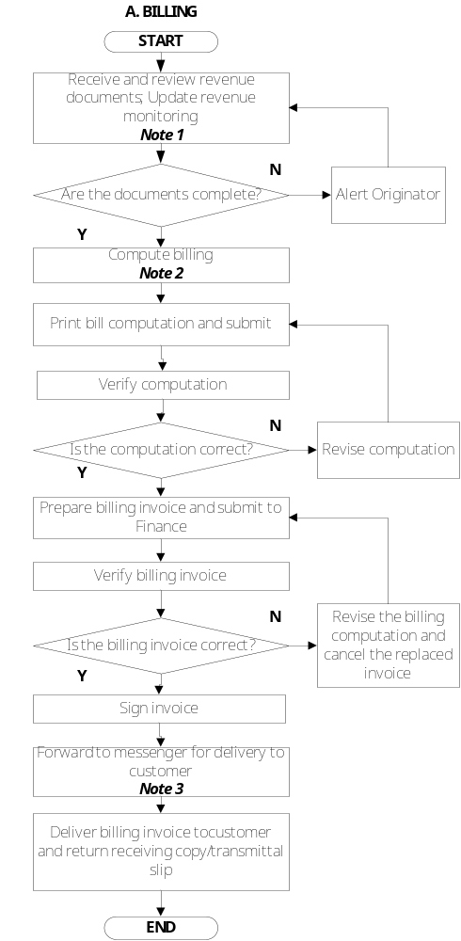 | Payroll Accountant  Account Managers  Training Head Marketing Assistant  GL-FI-FI-04 Guidelines in Billing Preparation  Billing Computation  Finance Head  AR Accountant  Billing Invoice  Communications Delivery Staff  Customers/AR  Accountant
RESPONSIBLE | ACTIVITY | INTERFACE
AR Accountant  Communications Delivery Staff  AR Accountant  AR Accountant/CDS | 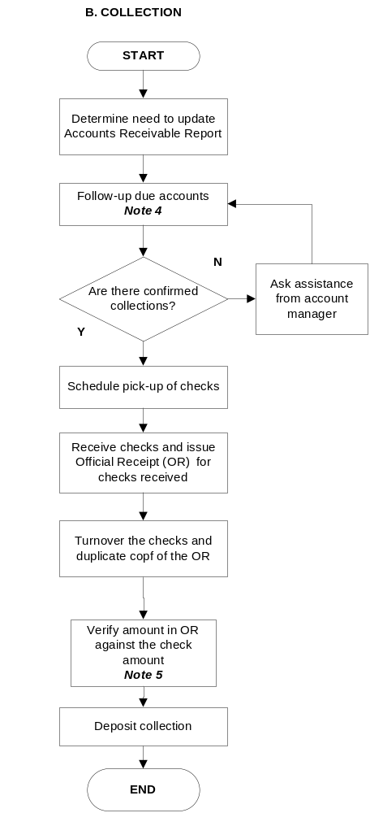 | AR Report  GL-FI-FI-05 Guidelines on Collections  Customers  Account Managers  Communications Delivery Staff  Customers  AR Accountant  Official Receipts  Deposit slip

Notes:
- Revenue documents such as timesheets, on-call reports and training registration forms must be approved; for revenue monitoring, it must be matched with the details stated on the contracts/supplements. For non-bodyshop billings, proceed to invoice preparation upon verification of correctness of revenue documents received.
- Get from Revenue Monitoring.xls the rates to be used in billing.
- Attach supporting revenue documents and receiving copy.
- If there are customer with past due accounts, prepare Statement of Account every month end.
- Check if there are cancelled Official Receipt. If there is any, make sure the original copy of the cancelled OR is intact.

- References

- Revenue Monitoring.xls
- Guidelines in Billing Preparation
- Guidelines on Collections

- Quality Records

- Bill Computation
- Invoice
- Revenue Montoring.xls
- Official Receipts

